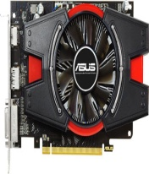 | Asus AMD/ATI HD 6670 1 GB GDDR5 Graphics Card | - 2560 x 1600 Maximum Digital Resolution  - 810 MHz GPU Clock Speed  - 1 GB GDDR5 Memory  - AMD CrossFireX Support  - AMD/ATI Radeon HD 6670 | Rs. 6458 | 0 | Rs. 6458
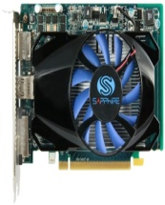 | Sapphire AMD/ATI HD 7750 1 GB GDDR5 Graphics Card | - 800 MHz GPU Clock Speed  - PCI-E 3.0 Bus Standard  - Shader Version 5.0  - 1 GB GDDR5 Memory  - AMD 3D Vision Support  - 2560 x 1600 Maximum Digital Resolution  - 450 W Power Supply Required | Rs. 7347 | 0 | Rs. 7347
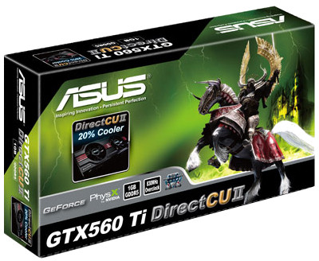 | Asus NVIDIA GTX 560 Ti Direct CUII 1 GB DDR5 Graphics Card | - 384 CUDA Cores  - 830 MHz GPU Clock Speed  - PCI-E 2.0 Bus Standard  - 1 GB DDR5 Memory  - NVIDIA 3D Vision Support  - 2560 x 1600 Maximum Digital Resolution  - NVIDIA GeForce GTX 560 Ti | Rs. 18868 | 0 | Rs. 18868
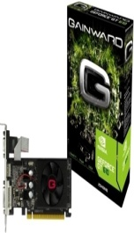 | Gainward NVIDIA 2GB DDR3 GT610 2 GB DDR3 Graphics Card | - 48 CUDA Cores  - 810 MHz GPU Clock Speed  - PCI-Express 2.0 Bus Standard  - 2 GB DDR3 Memory  - 300 W Power Supply Required  - NVIDIA GeForce GT 610 | Rs. 2945 | 0 | Rs. 2945
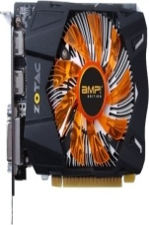 | ZOTAC NVIDIA GeForce GTX 650 AMP! Edition 2 GB GDDR5 Graphics Card | - 1189 MHz GPU Clock Speed  - PCI-E 3.0 Bus Standard  - 2 GB GDDR5 Memory  - 2560 x 1600 Maximum Digital Resolution  - 350 W Power Supply Required | Rs. 10671 | 0 | Rs. 10671
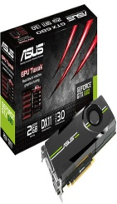 | Asus NVIDIA GTX 680 2 GB GDDR5 Graphics Card | - 1536 CUDA Cores  - 1058MHz GPU Clock Speed  - PCI-E 3.0 Bus Standard  - 2 GB GDDR5 Memory  - NVIDIA 3D Vision Support  - 2560 x 1600 Maximum Digital Resolution  - NVIDIA GeForce GTX 680 | Rs. 39420 | 0 | Rs. 39420
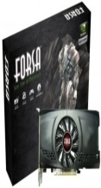 | Forsa NVIDIA GeForce GTX 550 Ti (NH-G550307D34-AG) 3 GB DDR3 Graphics Card | - 910 MHz GPU Clock Speed  - PCI-E 2.0 Bus Standard  - 3 GB DDR3 Memory  - NVIDIA 3D Vision Support  - NVIDIA GeForce GTX550 Ti  - NVIDIA SLI Support | Rs. 12999 | 16 | Rs. 10900
 | Sapphire AMD/ATI HD 7950 3GB GDDR5 With Boost 3 GB GDDR5 Graphics Card | - 850 MHz GPU Clock Speed  - 3 GB GDDR5 Memory  - PCI-E 3.0 Bus Standard  - Shader Version 5.0  - AMD HD3D Support  - 2560 x 1600 Maximum Digital Resolution  - 500 W Power Supply Required | Rs. 35000 | 25 | Rs. 26250
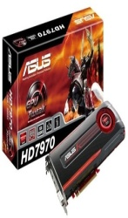 | Asus AMD/ATI HD 7970 3 GB GDDR5 Graphics Card | - 925 MHz GPU Clock Speed  - PCI-E 3.0 Bus Standard  - 3 GB GDDR5 Memory  - 3D Vision Support  - 2560 x 1600 Maximum Digital Resolution  - AMD ATI Radeon Radeon HD 7970  - Crossfire Support | Rs. 43000 | 6 | Rs. 39999
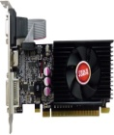 | Forsa NVIDIA GT630 4 GB SDDR3 Graphics Card | - 96 CUDA Cores  - 1620 MHz GPU Clock Speed  - Shader Version 5.0  - PCI-E 2.0 Bus Standard  - 4 GB DDR3 Memory  - 2560 x 1600 Maximum Digital Resolution  - NVIDIA GeForce GT 630 | Rs. 7000 | 21 | Rs. 5525
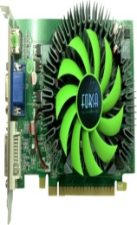 | Forsa NVIDIA GeForce GTS 450 4 GB SDDR3 Graphics Card | - 192 CUDA Cores  - 1566 MHz GPU Clock Speed  - PCI-E 2.0 Bus Std.  - 4 GB SDDR3 Memory  - NVIDIA 3D Vision Support  - 2-way NVIDIA SLI Support | Rs. 7000 | 0 | Rs. 7000
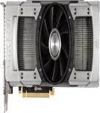 | Asus NVIDIA GTX 690 4 GB GDDR5 Graphics Card | - 3072 CUDA Cores  - 915 MHz GPU Clock Speed  - PCI-E 3.0 Bus Std  - 4 GB GDDR5 Memory  - NVIDIA 3D Vision Support  - 2560 x 1600 Maximum Digital Resolution  - NVIDIA GeForce GTX 690 | Rs. 71435 | 0 | Rs. 71435

